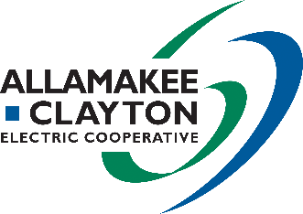 |  |  |  | EV Chargers
This institution is an equal opportunity provider. |  |  |  | 2022 Energy Efficiency Incentive Form
ELIGIBILITY CRITERIA
- New EV charger must be installed on cooperative’s lines.
- Incentive not to exceed the EV charger cost.
- Incentives are in place through December 31, 2022. Funds are limited so submit required documentation as soon as possible.
- Required documentation must be submitted within 3 months of EV charger install date.
- Additional eligibility criteria may apply. Program is subject to change or cancellation without notice. Contact cooperative for details.
- Required documentation listed below must be submitted no later than 3 months after EV charger install date.
  - This incentive form
  - A copy of your receipt or invoice for each item with purchase price(s) circled
  - For EV charger, include documentation showing the station has been installed
Allamakee-Clayton Electric Cooperative
PO Box 715
Postville, IA 52162-0715 | email: rwagner@acrec.coop
Submit required documentation to:

MEMBER INFORMATION (Please fill out entire section)
Member Name |  |  |  | Email  Email addresses will be used for cooperative communication only.
Address |  |  |  | Account |  | Phone
City | State |  | Zip | Date |  | Member Signature
Incentive for: Residential Farm Commercial Industrial Institution/Government Other:
INCENTIVE INFORMATION (Please fill in gray shaded boxes for requested incentives)
Equipment |  | Specifications |  |  | Quantity |  |  | Incentive | Total  Quantity x Incentive
Smart Electric Vehicle Charging Station with integrated metering |  | Must be CHARGE TM brand  Available through Allamakee-Clayton Electric Cooperative |  |  |  |  |  | $800
Total Incentive Amount Requested:
OFFICE USE ONLY
Approved Not Approved - Reason: |  |  |  |  |  |  | Total Incentive Issued: $
Cooperative Representative: |  |  |  |  |  |  | Date:

